Hymn
Be Thou my vision, O Lord of my heart,
naught be all else to me save that thou art;
thou my best thought in the day and night,
waking or sleeping, thy presence my light.

Be thou my wisdom, be thou my true word,
I ever with thee and thou with me, Lord;
thou my great Father, and I thy true son;
thou in me dwelling, and I with thee one.

Be thou my breast-plate, my sword for the fight,
be thou my armour, and be thou my might,
thou my soul’s shelter, and thou my high tower,
raise thou me heavenward, O Power of my power.

Riches I need not, nor man’s empty praise,
thou mine inheritance through all my days;
thou, and thou only, the first in my heart,
high King of heaven, my treasure thou art!

High King of heaven when battle is done,
grant heaven’s joy to me, O bright heaven’s sun;
Christ of my own heart, whatever befall,
still be my vision, O Ruler of all.
Be thou my vision: Words: Irish 8th century,
tr. Mary Byrne versified by Eleanor Hull. (Public Domain)

Leader: O God, come to our aid
All: O Lord, make haste to help us.
Leader: Glory be to the Father, and to the Son, and to the Holy Spirit
All: as it was in the beginning, is now, and ever shall be. Amen.

Prayer
Lord Jesus Christ,
time and time again throughout your ministry,
You made time to be still, to draw away from the crowds
so that in quietness you could reflect on your calling.
You needed those moments just as we need them in our turn.
So now we have made space in our lives,
away from the daily demands, away from the usual routine.
We are here, Lord, with time for you,
in stillness and in quietness to seek your will.
Lord Jesus Christ, use these moments
to refresh us, to feed us, to challenge us, to inspire us.
Fill them with your love and so may we be filled to overflowing. Amen
(Nick Fawcett, No Ordinary Man)

Reflection
“We know Peter’s frank and impetuous response: “You are the Christ, the Son of the living God” (Mt 16:16). So that we may be able to formulate it not only in abstract terms, but as an expression of a living experience, the fruit of a gift of the Father (cf. Mt 26:17), each one of us must let himself be touched personally by the question: “And you, who do you say I am? You who hear me spoken of, answer me. What do I really mean for you?” Peter’s divine illumination and response of faith came after a long period of living close to Jesus, hearing his words and observing his life and ministry (cf. Mt 16:21-24).

“In our case also, in order to make a more conscious profession of faith in Jesus Christ, we must like Peter, listen attentively and carefully. We must follow in the school of the first disciples who had become his witnesses and our teachers. At the same time we must accept the experience and testimony of no less than twenty centuries of history marked by the Master’s question and enriched by the immense chorus of responses of the faithful of all times and places.”
St John Paul II, General Audience, 7 January 1987
Reflection questions:
- Who is Jesus for me, what place does He have in my life?
- How do I engage with the ‘experience and testimony’ of the Church to help me grow in my relationship with Jesus?

Prayer – recited by all
Lord Jesus Christ, as we gather to worship you,
help us to see you here among us, so that we might equally see you everywhere.
Give us a clearer picture of your greatness and power, your love and your mercy,
your purpose for us and for all. Broaden our vision
and help us to catch a glimpse of you in all your glory,
filling us with joy, faith, hope and love,
now and always.
Amen.

Refection
“It is here that appears the dynamism of the life of a Christian, an apostle: I chose you to go forth. We must be enlivened by a holy restlessness: a restlessness to bring to everyone the gift of faith, of friendship with Christ. Truly, the love and friendship of God was given to us so that it might also be shared with others. We have received the faith to give it to others - we are priests in order to serve others. And we must bear fruit that will endure.

“All people desire to leave a lasting mark. But what endures? Money does not. Even buildings do not, nor books. After a certain time, longer or shorter, all these things disappear. The only thing that lasts for ever is the human soul, the human person created by God for eternity.

“The fruit that endures is therefore all that we have sown in human souls: love, knowledge, a gesture capable of touching hearts, words that open the soul to joy in the Lord. So let us go and pray to the Lord to help us bear fruit that endures. Only in this way will the earth be changed from a valley of tears to a garden of God.”
Cardinal Ratzinger, Homily 18 April 2005
Reflection questions:
- Do I consider my work to be touching human souls?
- How do I open ‘the soul (of students and colleagues) to joy in the Lord’?

Closing prayer
Lord God, your spirit of wisdom fills the earth
and teaches us in your ways. Look upon us teachers.
Let us strive to share our knowledge with gentle patience
and endeavor always to bring the truth to eager minds.
Grant that we may follow Jesus Christ, the way, the truth and the life,
forever and ever.
Amen.

Leader: Let us bless the Lord
All: Thanks be to God

Hymn Christ be beside me, Christ be before me,
Christ be behind me, King of my heart,
Christ be within me, Christ be before me,
Christ be above me, never to part.

Christ on my right hand, Christ on my left hand,
Christ all around me, shield in the strife.
Christ in my sleeping, Christ in my sitting,
Christ in my rising, light of my life.

Christ be in all hearts thinking about me.
Christ be in all tongues telling of me.
Christ be the vision in eyes that see me,
in ears that hear me, Christ ever be.
(Adapted from ‘St Patrick’s Breastplate ‘© James Quinn)

Prayer and Reflection
at the Beginning
of a New Year

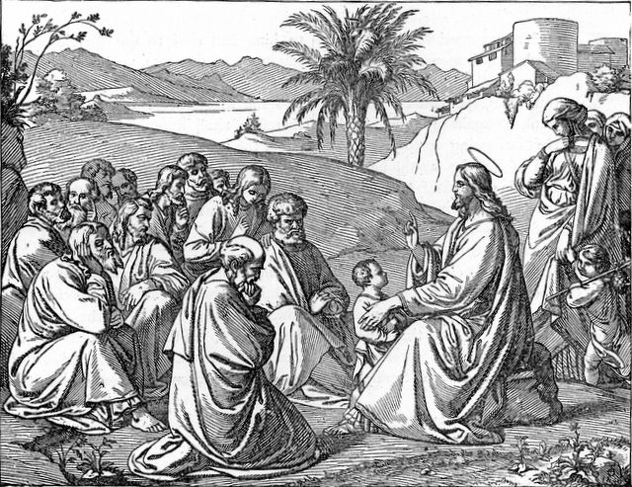
August 2016

